**Lab Ex 04:**

**Question 1: SRAM verification**

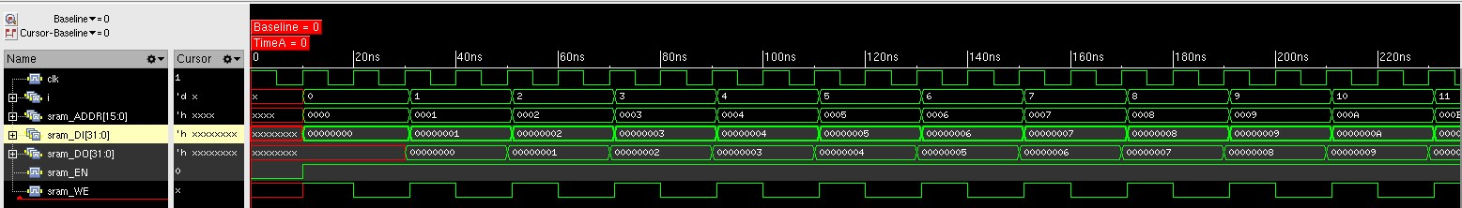Attaching the screenshot:

**Question 4: verification #2 multiplying two signed numbers**

We received the same results for this running compering the results to lab #2.

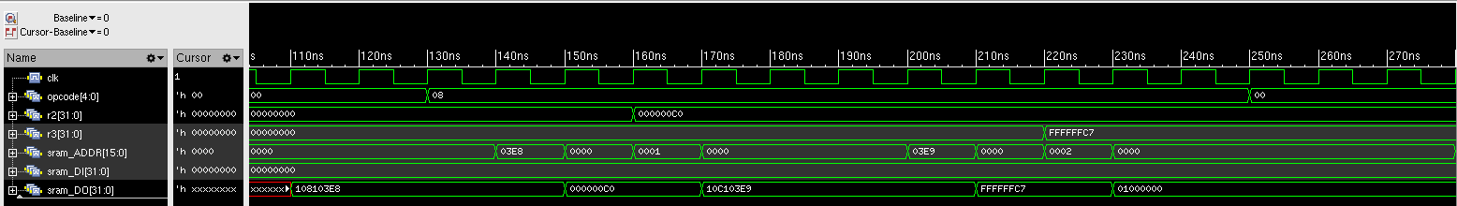Attaching the waveform showing the numbers being read into registers from memory:

Attaching the waveform showing the correct result being written back to memory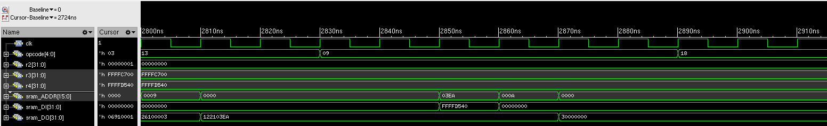:

**Question 5: verification #3 Fibonacci**

We received the same results for this running compering the results to lab #2.

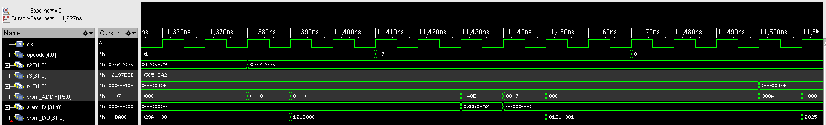Attaching the waveform showing the writing to the memory of the one before last value in the Fibonacci sequence. We can see the storing value is 0x03C50EA2 (63245986) which is the right value (fibo[39]):

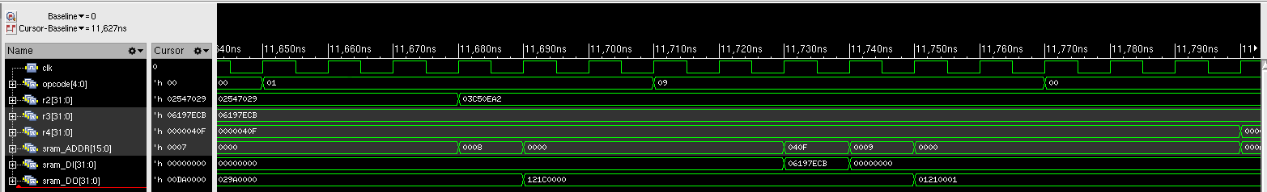  
Attaching the second waveform showing the writing to the memory of the last value in the Fibonacci sequence. We can see the storing value is 0x06197ECB (102334155) which is the right value (fibo[40]):

**Question 7: DMA verification**

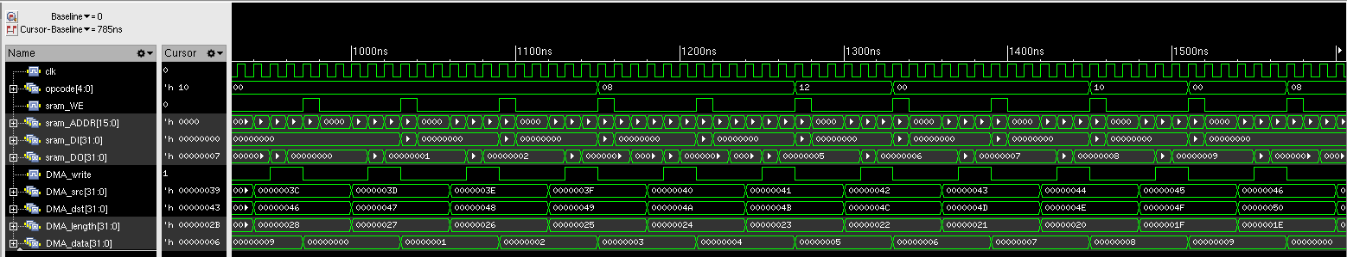We can see DMA operation is in progress and the program makes a parallel access to the memory while the DMA works.

After the running, we got some differences in the trace files comparing the run made at lab #2. We can see that we had some little bugs the lab #2 design, which now has been fixed.